Prof. Dr. Tamara lahTurnšek, PhD
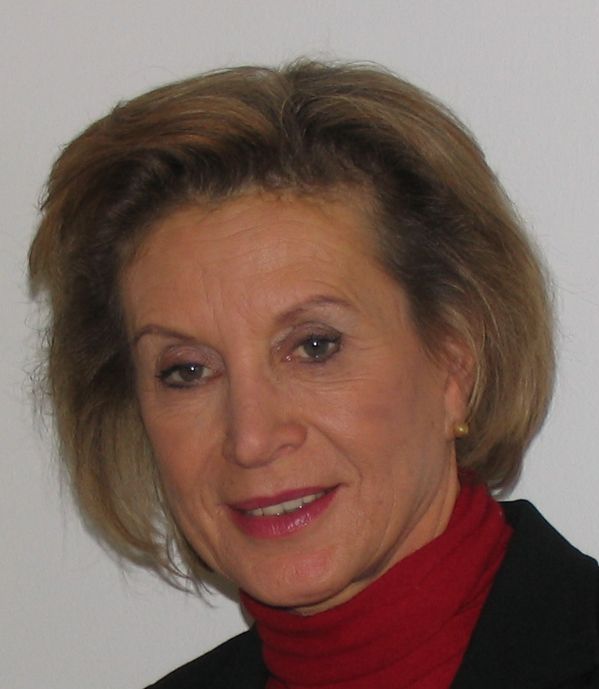 | Department of Toxicology and Cancer Biology  Tel. +386 (0) 5 9232-703GBM: 386-41-651-629  Fax +386 (0)1214-2870  tamara.lah@nib.si  http://www.nib.si

Main Research Goals
- Study of proteases and their inhibitors in physiological and pathological conditions in particular in cancerand inflammation.Focus on lysosomal enzymes -cathepsins, in tumours and (tumour) cells interacting with cells of tumour microenvironment; in vitrocell (co)cultures.
- Stem cell and tumour stemcellresearch.
- Cancer biologywith focus oninvasion, apoptosis/autophagy.
- Mutagenesis and carcinogenesis:DNA damage and repair; heavy metals, toxins and mutagens of natural origin - neutraceuticals.
- Cancer prevention(e.g. proteinase inhibitors from natural origin and their possible application in (cancer) therapy).
- Applied and clinical research on biomarkers / prognostic markers / targets in brain, breast and lung cancer.
Keywords, not underlined above:
autophagy, apoptosis, biomarkers, cathepsins, cell therapy, glioblastoma, , invasion

Group Members
A programme leader (TTL), 3 Projects leaders, 4 PhD – senior scientists, 2 post-docs, 8 PhD students, 1 technician

Horizon 2020 Health Calls of interest for collaboration:
For the year 2014,we identifiedcalls Horizon 2020 »Health, demographic change and wellbeing« calls, in which NIB could contribute:
PHC-01-2014: Understanding health, aging and disease:determinants, risk factors and pathways (can contribute only to 1st aim)
Deadline: 11th March 2014 (1st-stage), 19th August 2014 (2nd-stage)
PHC-05-2014: Health promotion and disease prevention: translating 'omics' into stratified approaches
Deadline: 11th March 2014 (1st-stage), 19th August 2014 (2nd-stage)
PHC-10-2014: Development of new diagnostic tools and technologies: in vitro devices, assays and platforms
Deadline: 11th March 2014 (1st-stage), 19th August 2014 (2nd-stage)
PHC-32-2014: Advancing bioinformatics to meet biomedical and clinical needs
Deadline 15th April 2014, (one-stage only)

For the year2015,additional calls are:
PHC-02-15: Understanding diseases: systems medicine
PHC-03-15: Understanding common mechanisms of diseases and their relevance in co-morbidities
PHC-14-2015: New therapies for rare diseases (GBM is recognized as rd by IRDiRC)
PHC-16-2015: Tools and technologies for advanced therapies
PHC33-2015: New approaches to improve predictive human safety testing

HCO

Previous and Current Research (related to Horizon 2020)

Dual role of stem cells in glioblastoma

VERBOVŠEK U, MOTALN H LEVIČAR N, ROTTER A, LAH TT. The duality of stem cells : double-edged sword in tumour evolution and treatment. In: RESENDE, Rodrigo (ed.), ULRICH, Henning (ed.). Trends in stem cell proliferation and cancer research. Dordrecht: Springer, cop. 2013, pp. 391-433.
It is hypothesized that cancer is a stem cell disease and one of actively investigated tumours of cancer stem cell origin is glioma and glioblastoma (GBM), the most malignant stage. The ifiltrative mode of invasion and the resistance to current therapies represent the major obstacle for successful therapy, both possibly due to the presence of GBM stem-like cells, with EMT activated migratome.
Other types of stem cells, associated with tumours and comprising tumour micro-environment are infiltrating haematopoietic stem cells, endothelial progenitor cells and mesenchymal stem cells (MSCs). Their role and differentiation pathways in tumour niches are the subject of intensive investigations, and unravelling the mechanisms underlying MSC-mediated imune-like modulation of tumour behaviour via paracrine and direct interactions with GBM stem cells may solve the dispute of their anti-malignant activity, which is currently contradictory to the hypothesis of possible GBM stem cells’ mesenchymal origin. Paracrine signals arising from MSC and GBM cells’ cross-talk impact the behavior of both cell types as was published recentlz by Motaln et al. In Cell Tranplanaton in 2012
By the same token, MSCs may represent novel therapeutic vectors for drug delivery, which are badly needed. Cell therapies, using stem cells are promising, due to their selective tumout tropism. Autologous MSCs are considered promising in some tumours, due to their immunomodulatory potential. However, MSC therapy may have adverse effects, as MSC’s pro-tumour behaviour was also evidenced. Combining cell based drug/gene delivery with anti-invasive strategies may prove appropriate for efficacy enhancement of conventional GBM treatment. This is a thoroug revisit of advantages and obstacles of recent pre-clinical trials using stem cells for glioma treatment.

Fir example, MSC and GBM cells interaction via gap junctions and cell fusion events increase invasion of GBM cells, what requires aditional modificaton and engeneering of the MSC to be used in cell therapy apparoaches. Taken from Schichor et al, 2012 (see below)

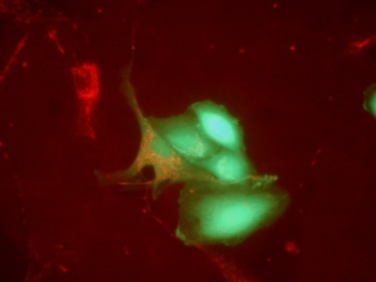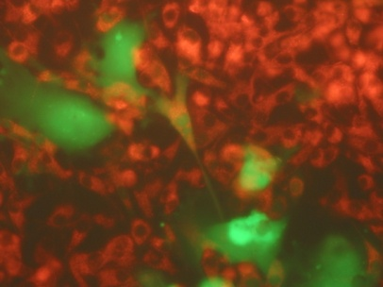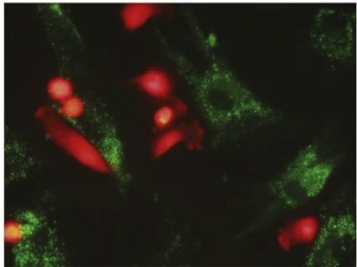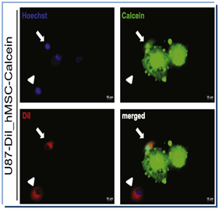
Functional syncytium formation of hMSCs with glioma cells: Fluorescent dye (Calcein, green) was transferred from pre-loaded hMSCs to U87 glioma cells. Transfer of calcein from one cell to another via gap junctions resulted in orange cells. Shown are hMSCs in green; U87 in red; nuclei (blue).

Proteases:

- Transcriptomic analyses: Gene expression data of GBM tumours& cell lines.

- Lysosomalcathepsins as biomarkers for glioma and carcinoma progression:
- invasion (cathepsin B –as target)
- apoptosis and autophagy, angiogenesis (cathepsin L-nuclear- as target)
- deciphering the role of cathepsin K (in invasion, functional regulation of stem cell niche, obesity….)
- immuneresponse, (obesity), cathepsinS
- adhesion, motility (cathepsin X)

For example, we recently demonstrated that Cathepsin L silencing in spheroid model enhanced glioma cells death induced by arsenite, as decribed bY Primon et al, (in press) in Exp.Cell Research-
As₂O₃ has long been used to treat cancer (leukaemia) and its use in GBM is being tested in clinical trial (III). CatL silending also increased arsenite-mediated apoptosis in spheroids of cultred cells (LEFT) and primary astrocytoma (LEFT) via elevated p53 expression, Bax/Bcl2 ratio and caspase 3/7 activity. The results have significant translational impact, since enhancement of arsenite-mediated apoptosis by CatL silencing would enable application of lower arsenite systemic doses to achieve desired cytotoxic effects in vivo.

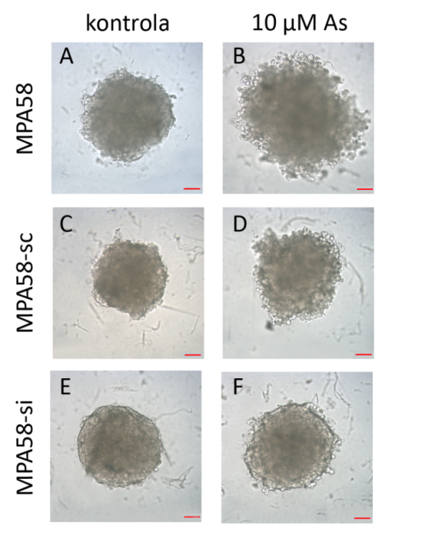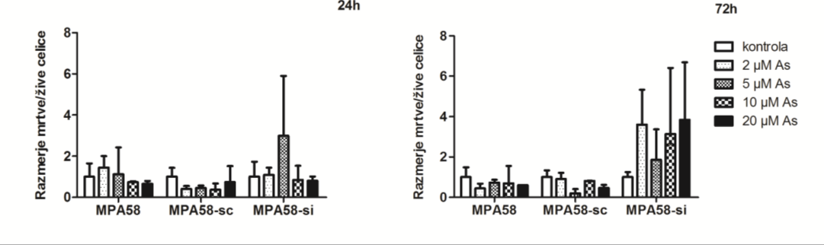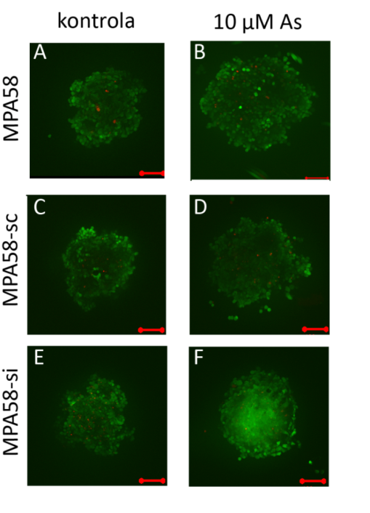

Techniques, Equipment and Expertise offered
At the Department of Systems Biology and Biotechnology at National Institute of Biology:
- Nanofluidic technology (FluidigmBioMark HD System)
Key Applications: Gene Expression, Single-Cell Gene Expression, SNP Genotyping, Protein Expression, Copy Number Variation, Sample Quantification for Sequencing. Offers systems approach for better understanding of biological system, high-throughput-screening.
- Real-time PCR (Applied Biosystems, Roche, Cephid) for applications: Gene expression, miRNA, SNP genotyping, copy number variation, protein thermal shift, high-resolution melt, pathogen detection The method offers excellent performance and reliability; point-of-care diagnostics.
- Droplet Digital PCR System (BioRad QX200)
Key applications: Cancer biomarker studies and copy number variation, pathogen detection, next generation sequencing, gene expression analysis, environmental monitoring, food testing. Offers absolute quantitation of target DNA molecules with high accuracy, precision and sensitivity, no need for dilution/standard curve.
- Isothermal LAMP amplification (GenieII)
Key applications: pathogen/pest detection, on-site application, SNPs typing, quantitative method Offers simple, rapid, specific and cost-effective nucleic acid (DNA, RNA) detection, point-of-care diagnostics.
- Next-generation sequencing (Ion Torrent, Roche GS Junior) and data analysis
Ion Torrent™ Technology is a sequencing technology that is simple, fast, cost effective and scalable.
Key applications: Targeted sequencing, exome sequencing, transcriptomeseq, genome.
The GS Junior System brings the power of 454 Sequencing Systems directly to the laboratory benchtop. Offers fast sequencing runs and straightforward data analysis on the attendant computer.
Key applications: Amplicon Sequencing, Sequence Capture, Whole Genome Sequencing of microbial organisms, Metagenomics and pathogen discovery, Transcriptome Sequencing.
- NGS data analysis - development and validation
offers applications: Amplicon Sequencing, Sequence Capture, Whole Genome Sequencing of microbial organisms, Metagenomics and pathogen discovery, Transcriptome Sequencing; pipelines for data analysis of from various NGS platforms e.g. Illumina, Roche, Ion Torrent.
- Biostatistics and bioinformatics
Experimental design for high through-put analysis, Statistical evaluation of data, modelling of biological processes, data integration, data visualisation,...
Key applications: data analysis in omics studies, data analysis and management.
- Automation of sample analysis
Pipetting robot for high through-put sample analysis and Software for fast and reliable qPCR data analysis (spin-off company Biosistemika)
Key applications: diagnostic and research laboratories
- Quality assurance and metrology
-ISO17025 standard is implemented in the laboratory from 2003
-Holder of National ETALON for amount of substance (food: GMOs)
Key applications: quantification and detection of nucleic acids, counting of nucleic acid molecule.

At the Department of Genetic Toxicology and Cancer Biologyat National Institute of Biology:

- Cell & Tissue culturing
Cell & Tissue culture facility:4x laminar flow hoods: CMaxPro130, M12, CatIIBiosafe 2 (EHRET),
Key applications:culturing of established cancer (stem) cell lines & normal (stem) cell lines; isolation of primary (spheroids) cultures of cancer (stem) cells & normal (stem) cells from tumour and adipose/umbilical cord tissue, respectively intercellular cross-talk studies
Cell & tissue Biobank
- Glioma samples (within GLIOMA project; access to cca 200 frozen tissue of LGG and HGG primary organotypicspheroids, primary cultures cells and whole blood.
-Access to Lung tumour samples – Biobank at University HospialGolnik
- Cellular processes analyses
Key applications: formonitoring cellular processes at gene and protein expression/activity level:
- RT-PCR (Biosciences), qPCR ABI PRISM 7700 (Applied Biosystems)
- Flow cytometer (Calibur BD),
- pectrofluorimeter with luminometer for microtitre plates (Tecan Geni; Spectrofluorimeter - multidetection reader Synergy (BioTech Instruments)
- Caplillary electrophoresis (Agylent).
- Single cell micromanipulation with CellEctor Plus system
Key applications: for cell selection and auto-recognition of single cells with bright field or fluorescence visualization; ultra precise cell aspiration and automated cell acquisition and deposition with full visual control for isolation of single cells in a format suitable for further in vitro culture and downstream molecular analysis with nanolitre volume reaction mixtures
- Imaging analyses
- Inverted (fluorescence) Nikon-eclipseTE300andNikon-eclipse Timicroscope equipped with digital cameras and Imaging Software NIS Elements.
- Upright (fluorescence) Nikon-E800 microscope
- Stereozoom-microscope (bright field) Nikon SMZ150
Key applications:Immuno-cytochemistry, Immuno-histochemsitry, live monitoring of cellular processes with labelled (fluorescent) substrates, Comet-assay, morphological analysis of changes in minute cell structures of proliferating/invading cells,…
- Animal models - Zebra fish (Daniorerio)
- maintenance of stock/breeding in the water-tank facility
- establishedprotocols for eco-toxicology studies and (transgenic)human cell injection studies
Key applications: genetic toxicology studies in zebra fish embryos, protein mis-expression (functional) studies in zebra fish embryos via transgenic cells’ (over-expressing or siRNA silenced) injection,…

Major current collaborations
In Slovenia:
- NIB, Dept. of Biotechnology and Systems Biology(Prof. Dr. MajaRavnikar)
- Josef Stefan Institute, Dept. of Knowledge Technologies (Prof. Dr. Nada Lavrač).
- University of Ljubljana, Faculty of Chemistry and Chemical Engineering (Prof.Dr. BrigitaLenarčič)
- University of Ljubljana, Faculty of Pharmacy, (Prof.Dr. Janko Kos).
- University Clinical Centre Ljubljana, Neurosurgerydept. (Dr.MarjanKoršič, MD)
- Institute of Oncology,(Prof. Dr. GregorSerša) - on electroporation&breast cancer
- University Clinic of Respiratory and Allergic Diseases Golnik, (Prof. Dr. TanjaČufer, MD) - on lung cancer

in Europe:

Italy:

Prof. Alberto Beltrami, Pathology– NeurosurgeryDept, University Hospital Udine

Prof.MassimoDomenicci, University of Modena

Germany:

Prof. JoergTonn&Dr. Christian Schichor, GrosshadernKlinik, Munich

Prof.ChristelHerold-Mende, University of Heidelberg, Heidelberg

Prof. Thomas Mulej, ThoraxKlinik, Heidelberg

Prof. Joachim Selbig, University of Potsdam, Potsdam

Dr. Johannes Schuchardt, MicrodiscoveryGbmh, Berlin

The Netherlands:

Prof. Cornelius van Noorden, Academic Medical Centre of the University of Amsterdam, Amsterdam

UK:

Prof.Geoffrey Pilkington, Portsmouth University, Portsmouth

Norway:

Prof. Rolf Bjerkvig, Bergen University, Bergen

Selected recent Grants
International:
EU-6FP Integrated Project # 503297: CANCERDEGRADOME: Extracellulaar Proteases and the Cancer Degradome: Innovative Diagnostic Markers, Therapeutic Targets and Tumour Imgaing Agents: PI : Dylan Edwards, UK; Co-PI :Tamara T. Lah, partner # 17, 2004-2009)

German - Slovene ERA-NET action Virtual Intitute projectwithin the INREMOS initiative of “Industrial important molecular lifesciences: “Systems Biology Tools Development for Cell Therapy and Drug Development - SYSTHER” (TTL co-PI, 2006-2011)

2007-2013 Programme: Slovenia – Italy Interreg GLIOMA -Determination of New Biomarkers of Brain Tumours -Glioma for Diagosis as Novel Targets for Therapy (cordinator and PI: Tamara T. Lah, 2011-2014)

National:Ecotoxicology, Toxicogenomics and Carcinogenesis: Programme P1-105-0245 (PI: Tamara T. Lah, 2009-2014)

Selected Publications
PODERGAJS, Neža, BREKKA, Narve, RADLWIMMER, Bernhard, HEROLD-MENDE, Christel, TALASILA, Krishna M., TIEMANN, Katja, RAJČEVIĆ, Uroš, LAH TURNŠEK, Tamara, BJERKVIG, Rolf, MILETIC, Hrvoje. Expansive growth of two glioblastoma stem-like cell lines is mediated by bFGF and not by EGF. In: Articles from 7th Conference of experimental and translational oncology, [April, 20-24, 2013, Portorož], (Radiology and Oncology, ISSN 1318-2099, vol. 47, no. 4). Ljubljana: Association of Radiology and Oncology, 2013, 330-337,
PRIMON, Monika, HUSZTHY, Peter C., MOTALN, Helena, TALASILA, Krishna M., TORKAR, Ana, BJERKVIG, Rolf, LAH TURNŠEK, Tamara.Cathepsin L silencing enhances arsenic trioxide mediated in vitro cytotoxicity and apoptosis in glioblastoma U87MG spheroids. Experimental cell research, ISSN 0014-4827, 2013, Oct 15;319(17):2637-48,
SCHICHOR Christian , ALBRECHT Valerie, KORTE , Benjamin, BUCHNER, Alexander , BUCHNER Rainer, MYSLIWIETZ Josef, PARON Igor, MOTALN, Helena, LAH TURNŠEK, Tamara, JÜRCHOTT Kathrin , SELBIG Joachim, TONN Joerg-Christian. Mesenchymal stem cells and glioma cells form a structural as well as a functional syncytium in vitro. Exp. neurol., 2012,. 234, i 1,. 208-219,.

MOTALN, Helena, GRUDEN, Kristina, HREN, Matjaž, SCHICHOR, Christian, PRIMON, Monika, ROTTER, Ana, LAH TURNŠEK, Tamara. Human mesenchymal stem cells exploit the immune response mediating chemokines to impact the phenotype of glioblastoma. Cell transplant. 2012, vol. no. 7,1529-1545.
TORKAR, Ana, BREGANT, S., DEVEL, Laurent, NOVINEC, Marko, LENARČIČ, Brigita, LAH TURNŠEK, Tamara, DIVE, Vincent. A novel photoaffinity-based probe for selective detection of cathepsin L active form.ChemBioChem. 2012, vol. 13, issue 17, 2616-2621,

GOLE, Boris, HUSZTHY, Peter C., POPOVIĆ, Mara, JERUC, Jera, ARDEBILI, Seyed Yousef, BJERKVIG, Rolf, LAH TURNŠEK, Tamara. The regulation of cysteine cathepsins and cystatins in human gliomas. Int J Cancer 2012, vol. 131, issue 8, str. 1779-1789,.

CASTINO, Roberta, PUCER, Anja, VENERONI, Roberta, MORANI, Federica, PERACCHIO, Claudia, LAH TURNŠEK, Tamara, ISIDORO, Ciro. Resveratrol reduces the invasive growth and promotes the acquisition of a long-lasting differentiated phenotype in human glioblastoma cells. J. agric. food chem., 2011, vol. 59, no. 8,. 4264-4272.
TORSVIK, Anja, PRIMON, Monika, LAH TURNŠEK, Tamara, MOTALN, Helena, et al. Spontaneous malignant transformation of human mesenchymal stem cells reflects cross-contamination : putting the research field on track - letter. Cancer research, ISSN 0008-5472, 2010, vol. 70, no. 15, str. 6393-6396.

